1)

Image 1
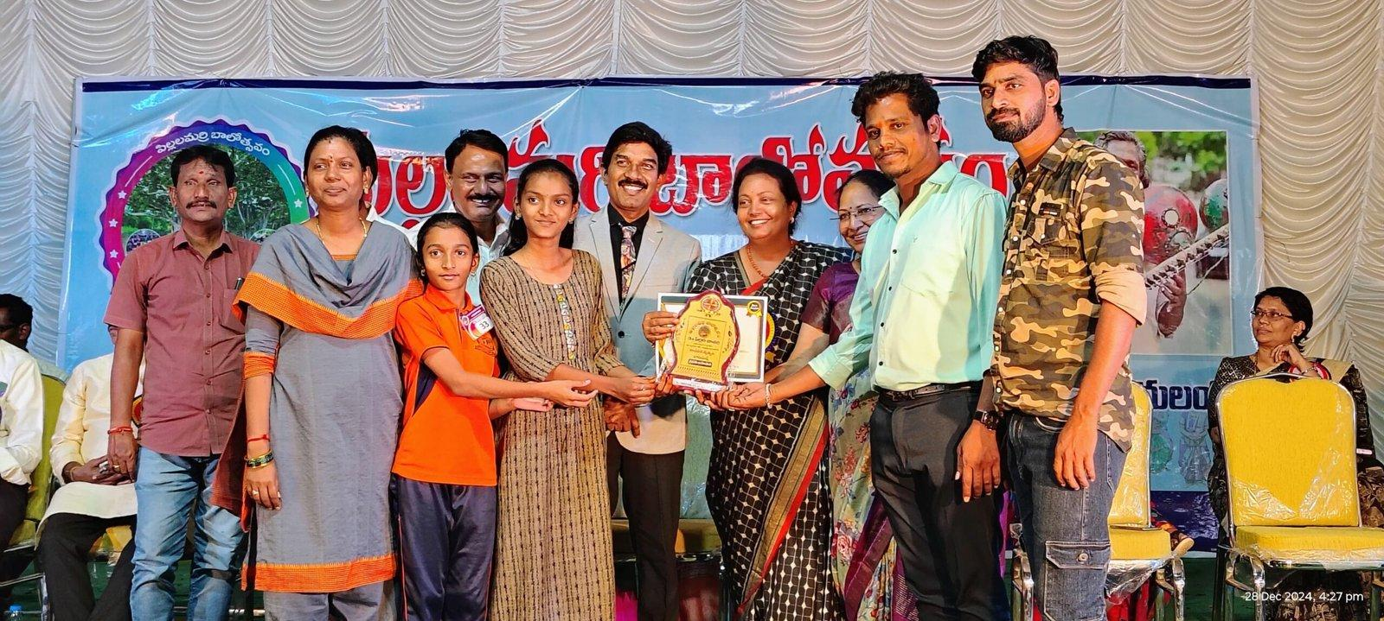

Imege 2

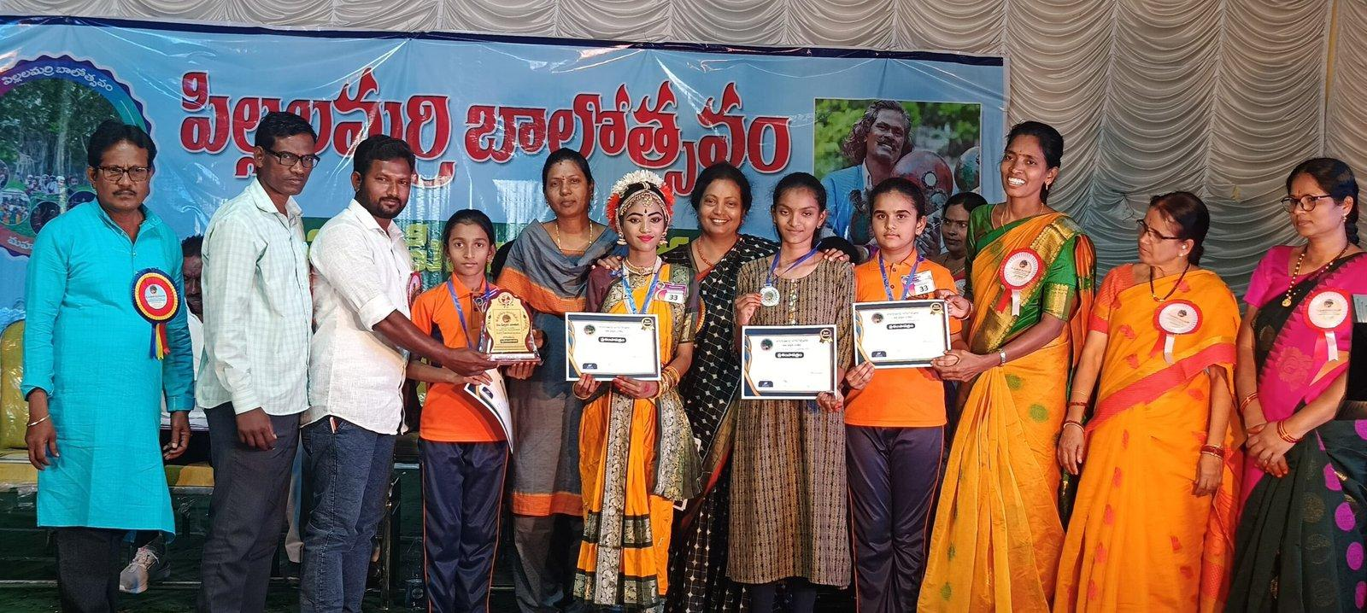

01 — Telugu Katha Rachana
Student: Ananya
Class: 6th
Activity: Telugu Katha Rachana
Event: Pillalamari Balotsavam
Location: Mahabubnagar
Year: 2024/2025 — To be verified
Context:
Ananya of Class 6 participated in Telugu Katha Rachana at Pillalamari Balotsavam, Mahabubnagar, showcasing her creativity and storytelling skills in the Telugu language.
Photos:
[Insert relevant photo(s) here]

02 — Padyam Bhavam
Student: Lasya
Class: 6th
Activity: Padyam Bhavam
Event: Pillalamari Balotsavam
Location: Mahabubnagar
Year: 2024/2025 — To be verified
Context:
Lasya of Class 6 participated in Padyam Bhavam at Pillalamari Balotsavam, Mahabubnagar, presenting Telugu poetry through expressive performance.
Photos:
[Insert relevant photo(s) here]

03 — Group Song / Dance
Students: Chaithra and Chatura
Class: 7th
Activity: Group Song / Dance
Event: Pillalamari Balotsavam
Location: Mahabubnagar
Year: 2024/2025 — To be verified
Context:
Chaithra and Chatura of Class 7 participated in a group song and dance performance at Pillalamari Balotsavam, Mahabubnagar, showcasing teamwork, coordination and cultural expression.

3)

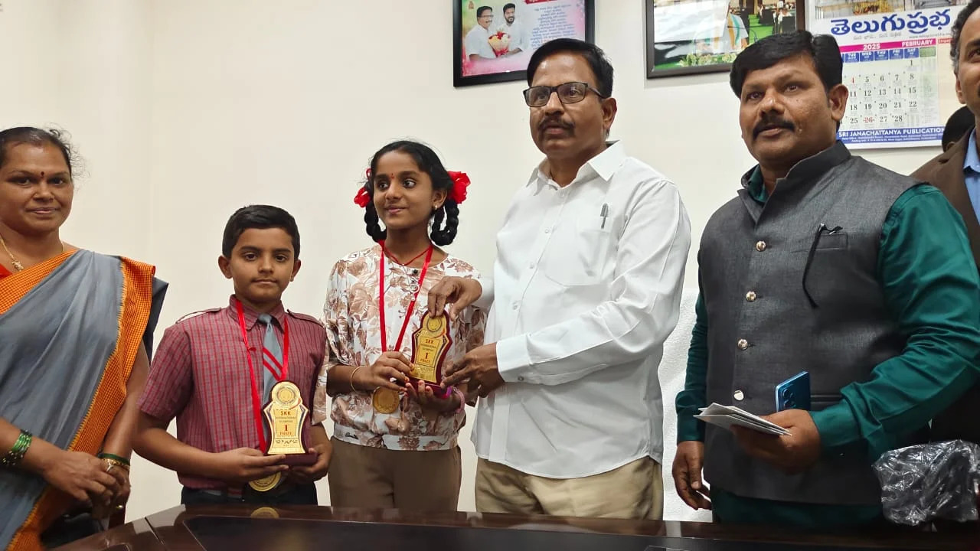

Champions of Knowledge: State Toppers at SKK Olympiad!

We are thrilled to celebrate a remarkable achievement by our bright minds!
Pranav from 3rd Standard and V. Chetan from 5th Standard made us proud by securing the State 1st Prize in the prestigious SKK International Olympiad 2023.
Their dedication, focus, and brilliance truly reflect the academic excellence we nurture at Universal Central School. This victory at the state level has brought immense joy to the entire school community. It is a proud moment for both the students and their mentors.
We salute their spirit of excellence and wish them continued success in the future.
Congratulations, Pranav and Chetan – you’ve made us shine on the state map!

4)
2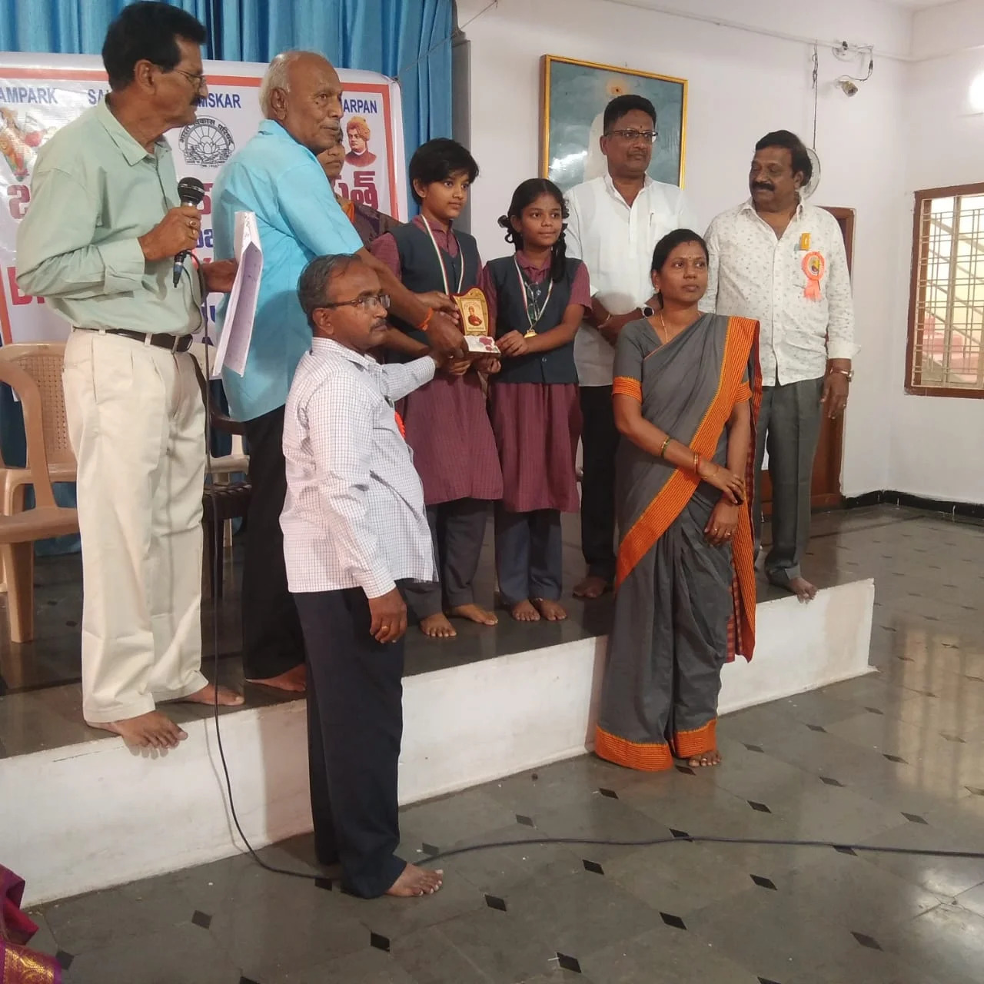

Quiz Masters in Action: 2nd Prize at Bharat Ko Jano!Another proud moment for Universal Central School as our students earned the 2nd Prize(Vishwa Chaitanya and Varshini from 7th Standard) in the Bharat Ko Jano Quiz Competition!
The team demonstrated exceptional general knowledge, teamwork, and quick thinking throughout the contest.
This victory is a reflection of our school’s commitment to holistic learning and awareness.
Our quiz wizards made us proud with their enthusiasm and presence of mind.
Their win inspires others to engage in learning beyond textbooks.
Kudos to the team for making knowledge fun and competitive!
Keep buzzing with brilliance – your curiosity leads the way

3)

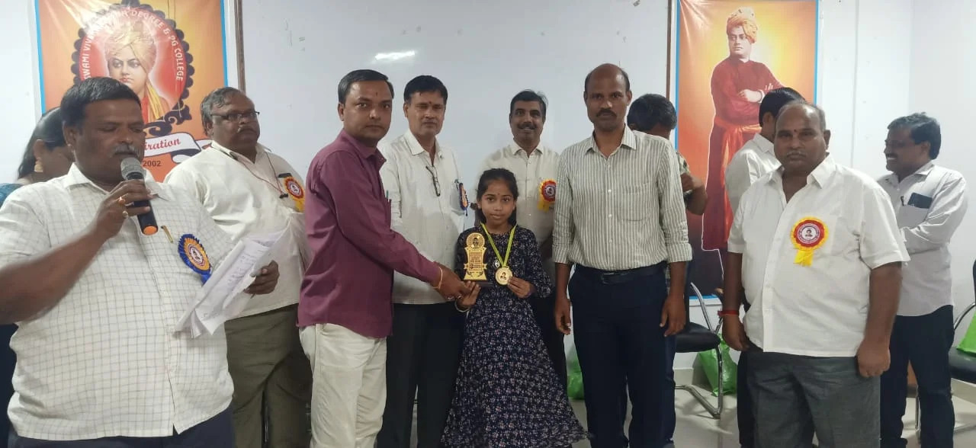

Math Mind on the Move: District Winner in Ramanujan Test!

Congratulations to Sahithi from 5th Class for her outstanding performance in the Srinivasa Ramanujan Maths Talent Test!
She secured the District 3rd Prize, showcasing her sharp analytical skills and love for numbers.
This achievement is a true reflection of the mathematical culture we promote at Universal Central School.
Sahithi’s success adds another bright feather to our academic achievements.
Her win inspires other students to pursue excellence in Mathematics.
We are proud of her and wish her even greater heights in future competitions.
Well done, Sahithi – keep solving, keep shining!

4)

Abacus Wizards Win Big!
Main
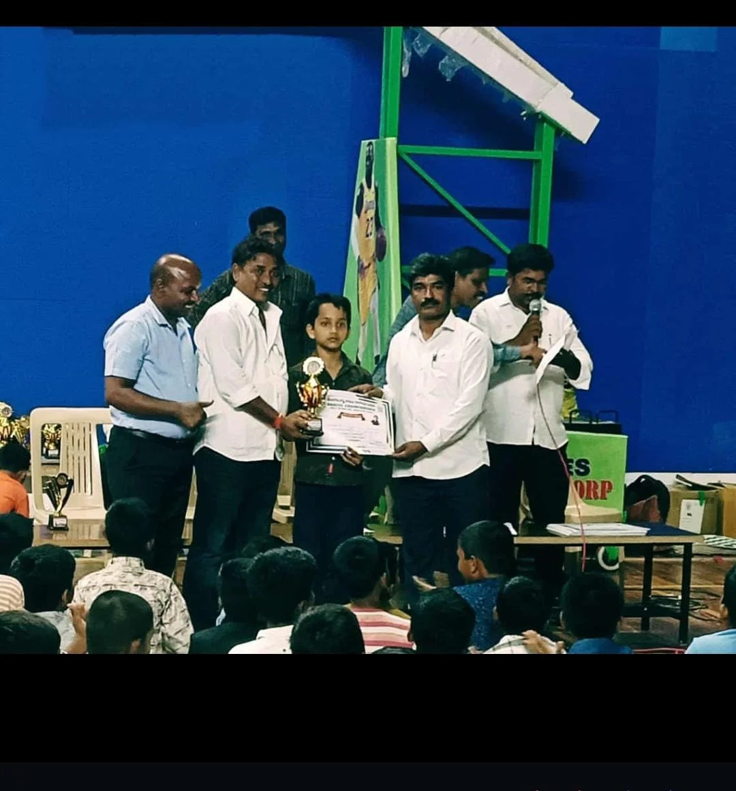

Universal Central School continues to make its mark with pride!
Our talented students clinched the top 3 prizes at the Abacus Championship organized by Telangana Rastra Janapadalu Sangam, Mahabubnagar.
R. Abhijith (5th Class) secured the 1st prize in Seniors, while Naren (5th Class) bagged the 2nd prize.
In the Juniors category, Gouthami Lasya (4th Class) earned a proud 3rd prize.
This achievement reflects their sharp minds and quick calculations!
We are immensely proud of our math marvels for their outstanding performance.
Keep counting the wins, champs – the future is yours to conquer!

